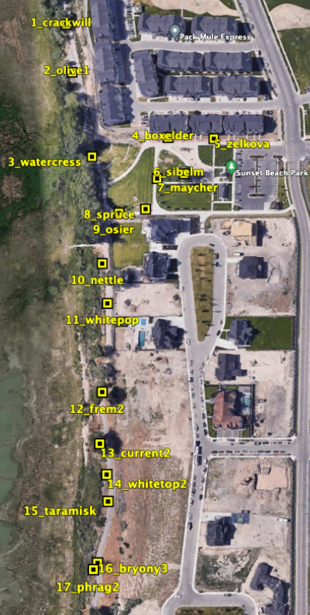
Botany Cryptogram Activity*
WHAT: An activity to learn about plants in sunset beach park and along the Utah Shoreline Trail.

HOW: To solve the puzzle, start at plaque #1 (see map). From there you will be solving a cryptogram as you proceed south, visiting all of the plants along the trail, 1-17 (1 mile loop walk). At each plant, find the plaque that outlines plant family, genus, species, author, and common name. On the plaques, the first line is the common name shown in all CAPITAL LETTERS. The second line is the scientific name in italics, with the genus first and the species second, followed by the author. The third line is the plant family to which the species belongs. Using the key below, fill in the blanks with the correct letter to find the secret message! The key goes in order from plaque 1 - 17. Good luck!

- The letter for number 3 is the third letter of the common name.
- The letter for number 8 is the first letter of the genus name.
- The letter for number 4 is the first letter of the genus name.
- The letter for number 2 is the last letter of the species name.
- The letter for number 15 is the third letter of the genus name.
- The letter for number 9 is the first letter of the genus name
- The letter for number 11 is the last letter of the common name
- The letter for number 14 is the first letter of the family name.
- The letter for number 10 is the first letter of the third part of the common name.
- The letter for number 6 is the fourth letter of the genus name.
- The letter for number 7 is the second letter in the common name.
- The letter for number 13 is the first letter of the species name.
- The letter for number 12 is the third letter in the family name.
- The letter for number 1 is the first letter of the family name.
- The letter for number 16 is the second letter in the common name.
- The letter for number 5 is the third letter in the common name.
- The letter for number 17 is the last letter of the first word in the common name.
_ _ T _ _ _ _ S T _ _ S T _ _ _
1 2 3 4 5 6 7 8 9 10 11

_ _ _ _ _ _ T S
12 13 14 15 16 17

Key to Botany Cryptogram Activity

- Crack Willow Salix x fragilis L. Salicaceae
- Russian Olive Elaeagnus angustifolia L. Elaeagnaceae
- Watercress Nasturtium officinale W.T.Aiton Brassicaceae
- Box Elder Acer negundo L. Sapindaceae
- Zelkova Zelkova serrata (Thunb.) Makino Ulmaceae
- Siberian Elm Ulmus pumila L. Ulmaceae
- Bird Cherry Prunus padus L. Rosaceae
- Blue spruce Picea pungens Engelm. Pinaceae
- Red Osier Dogwood Cornus sericea L. Cornaceae
- Stinging Nettle Urtica dioica L. Urticaceae
- White Poplar Populus alba L. Salicaceae
- Fremont's Cottonwood Populus fremontii S.Watson Salicaceae
- Golden Current Ribes aureum Pursh Grossulariaceae
- Whitetop Cardaria draba (L.) Desv. Brassicaceae
- Tamarisk Tamarix chinensis L. Tamaricaceae
- Bryony Bryonia alba L. Cucurbitaceae
- Common Reed Phragmites australis L. Poaceae

Activity spells:

BOTANY IS THE STUDY OF PLANTS

* Activity created by Isaac Olsen and Gabriel Baldonado, students of the UVU Botany 2050 Summer 2023 Excelerate class under the direction of Dr. Ashley N. Egan

